**Assignment - 1**

|  |  |
| --- | --- |
| Assignment Date | 19 September 2022 |
| Student Name | M.VIDHYA SRI |
| Student Roll Number | 211519104182 |
| Maximum Marks | 2 Marks |
| Team Name | DareDevils |

**Question-1:**

1. Create form of type input, text, email, password, radio button, text area, drop down and navigate to success page and display files of form in table.

**Solution:**

|  |  |
| --- | --- |
| <html>  <head>  <title>Registration Form</title>  <script type="text/javascript">  function display()  {  var name = document.getElementById("name").value;  var email = document.getElementById("email").value;  var gender = document.getElementById("gender").value;  var year = document.getElementById("year").value;  var co = document.getElementById("co").value;  var batch = document.getElementById("batch").value;  document.writeln("<html><body>");  document.writeln("<table border='1'><tr>");  document.writeln("<th>Name</th><th>Email</th><th>Gender</th><th>Courses Offered</th><th>Batch</th><th>Year</th>");  document.writeln("</tr>"); document.writeln("<tr><td>"+name+"</td><td>"+email+"</td><td>"+gender+"</td><td>"+co+"</td><td>"+batch+"</td><td>"+year+"</td>");  document.writeln("</tr></table>");  document.writeln("</body></html>");  }  </script>  </head>  <body>  <center><br/>  <h1><b>Registration Form</b></h1><br/>  <form method="post" onsubmit="display()">  <label for="name">Name:</label>  <input type="text" id="name" name="name" placeholder="Enter name"/><br/><br/>  <label for="email">Email:</label>  <input type="email" id="email" name="email" placeholder="Enter email"/><br/><br/>  <label for="pwd">Password:</label>  <input type="password" id="pwd" name="pwd" placeholder="Enter password"/><br/><br/>  <label for="address">Address:</label>  <textarea id="address" name="address" rows="4" cols="50"></textarea><br/><br/>  <label for="gender">Gender: </label>  <input type="radio" id="gender" name="gender" value="male">Male</input>  <input type="radio" id="gender" name="gender" value="female">Female</input><br/><br/>  <label for="pl">Courses Offered: </label><br/>  <input type="checkbox" id="co" name="co" value="matlab">Matlab</input><br/>  <input type="checkbox" id="co" name="co" value="nodejs">NodeJS</input><br/>  <input type="checkbox" id="co" name="co" value="python">Python</input><br/>  <input type="checkbox" id="co" name="co" value="ui/ux">UI/UX</input><br/><br/>  <label for="year">Year:</label>  <select name="year" id="year">  <option value="first">I</option>  <option value="second">II</option>  <option value="third">III</option>  <option value="fourth">IV</option>  </select><br/><br/>  <label for="batch">Preferred Batch:</label>  <select name="batch" id="batch">  <option value="sep">September</option>  <option value="oct">October</option>  <option value="nov">November</option>  </select><br/><br/>  <input type="submit" value="SUBMIT"/><br/><br/>  </form>  </center>  </body>  </html>                **Output:** |  |

**Question-2:**

1. **For CSS create external style sheet for above task(separate css file and link that in html).**

**Solution:**

<html>

<head>

<link rel="stylesheet" href="Q2stylesheet.css" type="text/css" />

<title>Registration Form</title>

<script type="text/javascript">

function display()

{

var name = document.getElementById("name").value;

var email = document.getElementById("email").value;

var gender = document.getElementById("gender").value;

var year = document.getElementById("year").value;

var co = document.getElementById("co").value;

var batch = document.getElementById("batch").value;

document.writeln("<html><body>");

document.writeln("<table border='1'><tr>");

document.writeln("<th>Name</th><th>Email</th><th>Gender</th><th>Courses Offered</th><th>Batch</th><th>Year</th>");

document.writeln("</tr>"); document.writeln("<tr><td>"+name+"</td><td>"+email+"</td><td>"+gender+"</td><td>"+co+"</td><td>"+batch+"</td><td>"+year+"</td>");

document.writeln("</tr></table>");

document.writeln("</body></html>");

}

</script>

</head>

<body>

<center><br/>

<h1><b>Registration Form</b></h1><br/>

<form method="post" onsubmit="display()">

<label for="name">Name:</label>

<input type="text" id="name" name="name" placeholder="Enter name"/><br/><br/>

<label for="email">Email:</label>

<input type="email" id="email" name="email" placeholder="Enter email"/><br/><br/>

<label for="pwd">Password:</label>

<input type="password" id="pwd" name="pwd" placeholder="Enter password"/><br/><br/>

<label for="address">Address:</label>

<textarea id="address" name="address" rows="4" cols="50"></textarea><br/><br/>

<label for="gender">Gender: </label>

<input type="radio" id="gender" name="gender" value="male">Male</input>

<input type="radio" id="gender" name="gender" value="female">Female</input><br/><br/>

<label for="pl">Courses Offered: </label><br/>

<input type="checkbox" id="co" name="co" value="matlab">Matlab</input><br/>

<input type="checkbox" id="co" name="co" value="nodejs">NodeJS</input><br/>

<input type="checkbox" id="co" name="co" value="python">Python</input><br/>

<input type="checkbox" id="co" name="co" value="ui/ux">UI/UX</input><br/><br/>

<label for="year">Year:</label>

<select name="year" id="year">

<option value="first">I</option>

<option value="second">II</option>

<option value="third">III</option>

<option value="fourth">IV</option>

</select><br/><br/>

<label for="batch">Preferred Batch:</label>

<select name="batch" id="batch">

<option value="sep">September</option>

<option value="oct">October</option>

<option value="nov">November</option>

</select><br/><br/>

<input type="submit" value="SUBMIT"/><br/><br/>

</form>

</center>

</body>

</html>

**Output:**

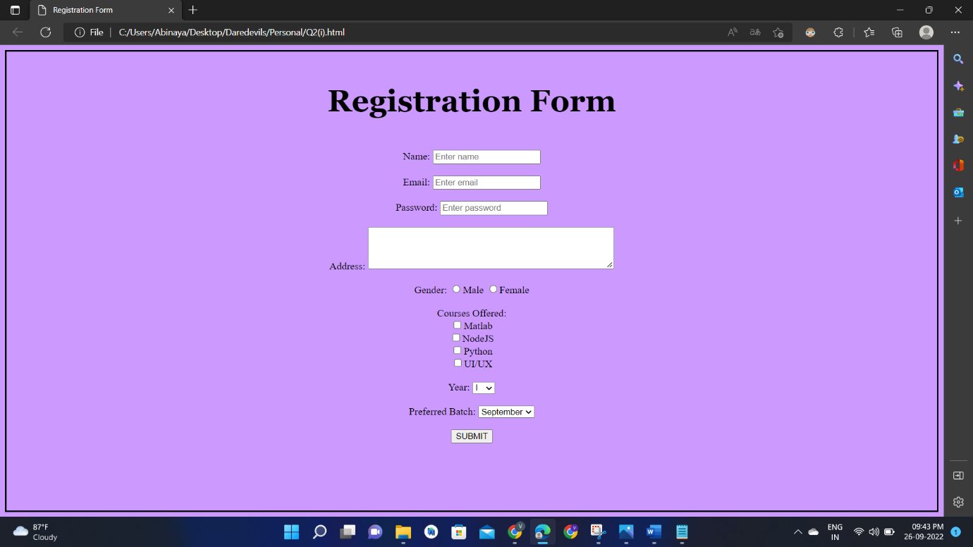

**Question 3:**

**3.Create sample program for Flask HTTP methods (list or map and perform operations of PUT, GET DELETE and POST).**

**Solution:**

from flask import Flask,request,json

app=Flask(__name__)

fruits={"1":"cat", "2":"dog" , "3":"fish" , "4":"lovebird" , "5":"cow", "6":"rat" ,"7":"hamster"}

@app.route('/data' ,methods=['GET','POST'])

def api():

if request.method=='GET':

return fruits

if request.method=='POST':

data=request.json

fruits.update(data)

return 'data got inserted'

@app.route("/data/<id>",methods=['PUT'])

def update(id):

data=request.form['items']

fruits[str(id)]=data

return 'data updated'

@app.route("/data/<id>",methods=["DELETE"])

def deleteoperation(id):

fruits.pop(str(id))

return 'data deleted'

if__name__=='__main__':

app.run(debug=True)